**Assignment 1- Atomic and electronic structure of materials**

**Bhuvanesh P – MM19B027**

**1 . Bravais Lattices**

1. Simple cubic

1.0

4.0000000000 0.0000000000 0.0000000000

0.0000000000 4.0000000000 0.0000000000

0.0000000000 0.0000000000 4.0000000000

Ar

1

Direct

0.000000000 0.000000000 0.000000000

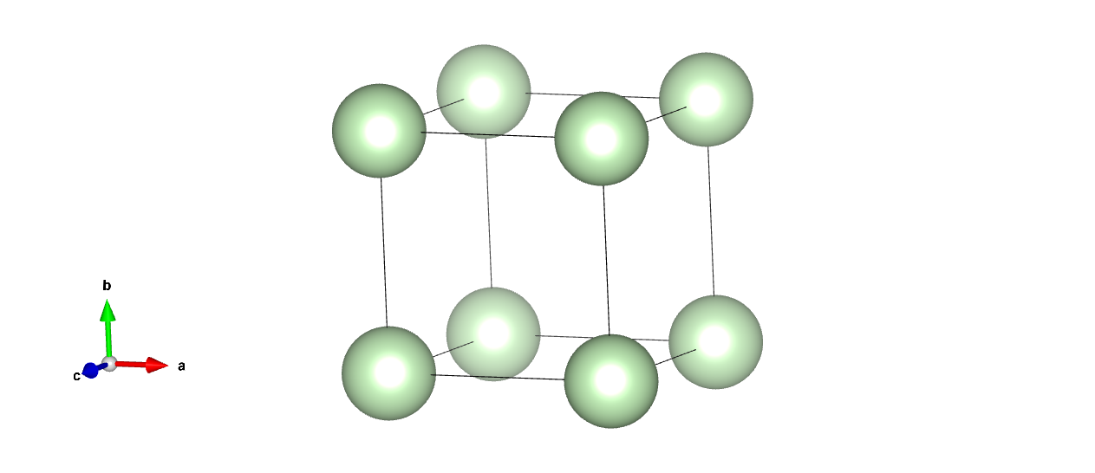

2. Body centred cubic

1.0

4.0000000000 0.0000000000 0.0000000000

0.0000000000 4.0000000000 0.0000000000

0.0000000000 0.0000000000 4.0000000000

Ar

2

Direct

0.000000000 0.000000000 0.000000000

0.500000000 0.500000000 0.500000000

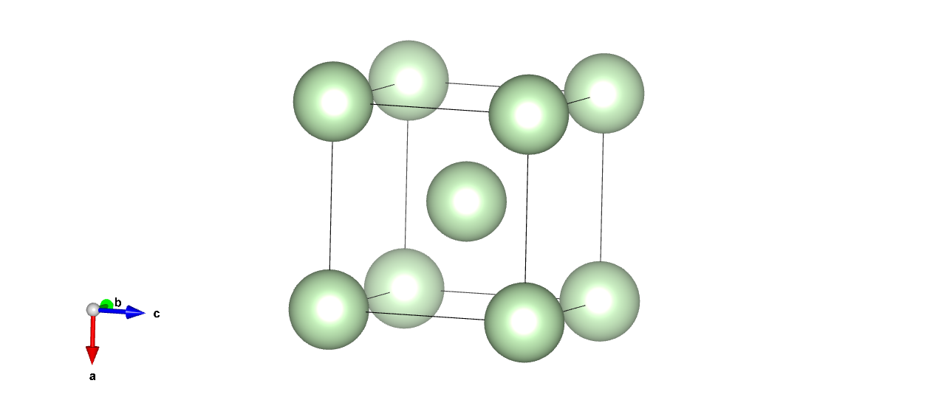

3. Face centred cubic

1.0

4.0000000000 0.0000000000 0.0000000000

0.0000000000 4.0000000000 0.0000000000

0.0000000000 0.0000000000 4.0000000000

Ar

4

Direct

0.000000000 0.000000000 0.000000000

0.500000000 0.500000000 0.000000000

0.000000000 0.500000000 0.500000000

0.500000000 0.000000000 0.500000000

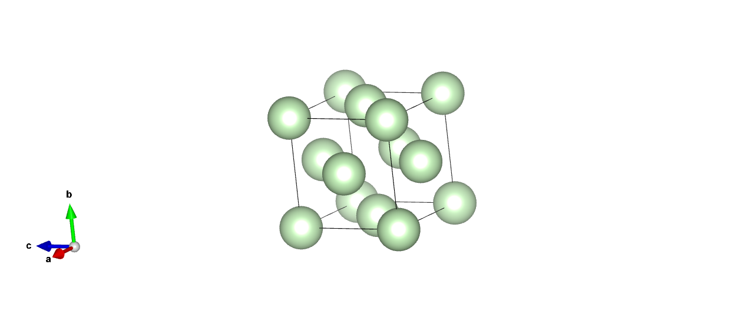

4. Primitive Tetragonal

1.0

4.0000000000 0.0000000000 0.0000000000

0.0000000000 4.0000000000 0.0000000000

0.0000000000 0.0000000000 5.0000000000

Ar

1

Direct

0.000000000 0.000000000 0.000000000

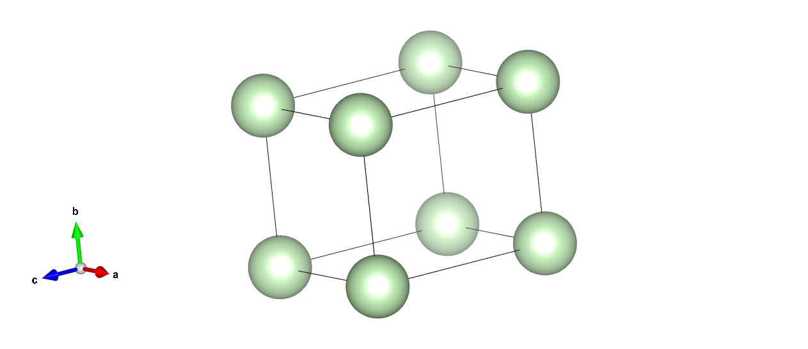

5. Body centered tetragonal

1.0

4.0000000000 0.0000000000 0.0000000000

0.0000000000 4.0000000000 0.0000000000

0.0000000000 0.0000000000 5.0000000000

Ar

2

Direct

0.000000000 0.000000000 0.000000000

0.500000000 0.500000000 0.500000000

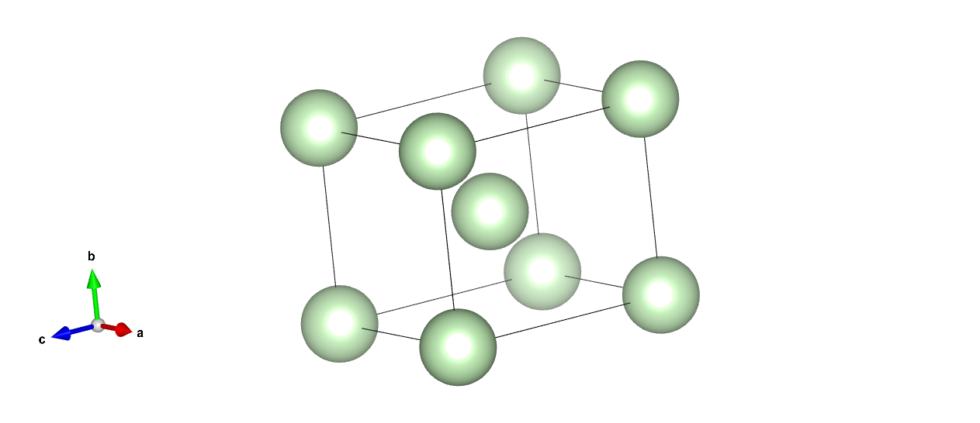

6. Primitive Orthorhombic

1.0

4.0000000000 0.0000000000 0.0000000000

0.0000000000 4.5000000000 0.0000000000

0.0000000000 0.0000000000 5.0000000000

Ar

1

Direct

0.000000000 0.000000000 0.000000000

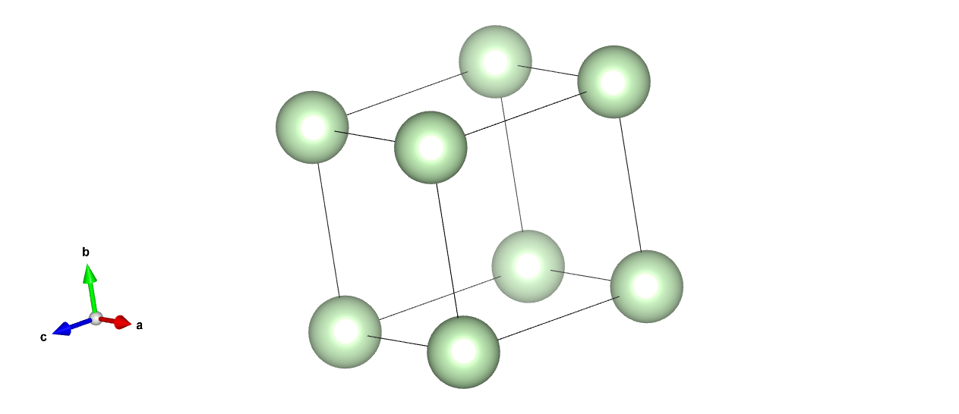

7. Body Centered Orthorhombic

1.0

4.0000000000 0.0000000000 0.0000000000

0.0000000000 4.5000000000 0.0000000000

0.0000000000 0.0000000000 5.0000000000

Ar

2

Direct

0.000000000 0.000000000 0.000000000

0.500000000 0.500000000 0.500000000

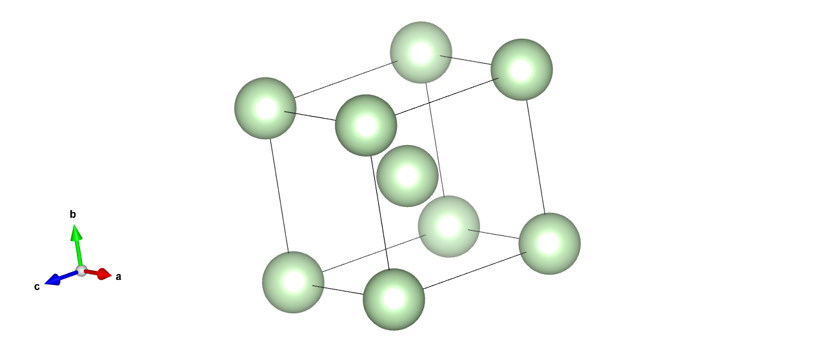

8. Base Centered Orthorhombic

1.0

4.0000000000 0.0000000000 0.0000000000

0.0000000000 4.5000000000 0.0000000000

0.0000000000 0.0000000000 5.0000000000

Ar

2

Direct

0.000000000 0.000000000 0.000000000

0.500000000 0.000000000 0.500000000

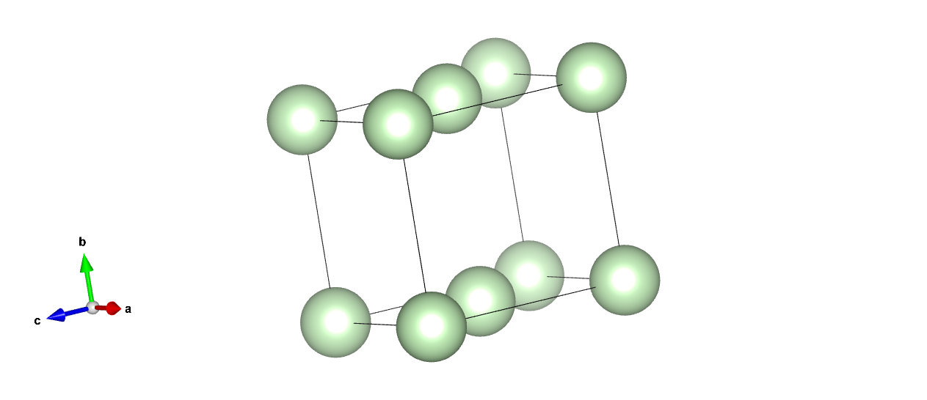

9. Face Centered Orthorhombic

1.0

4.0000000000 0.0000000000 0.0000000000

0.0000000000 4.5000000000 0.0000000000

0.0000000000 0.0000000000 5.0000000000

Ar

4

Direct

0.000000000 0.000000000 0.000000000

0.500000000 0.000000000 0.500000000

0.500000000 0.500000000 0.000000000

0.000000000 0.500000000 0.500000000

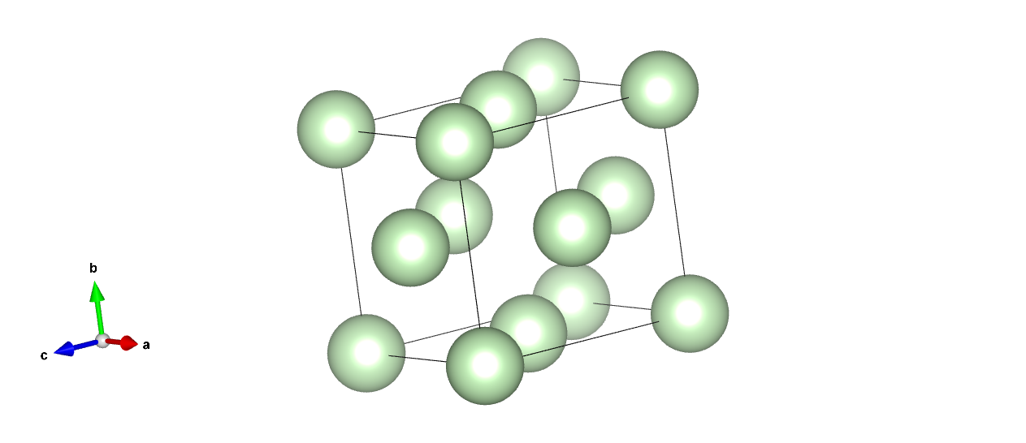

10. Primitive Hexagonal

1.0

4.0000000000 0.0000000000 0.0000000000

-2.0000000000 3.4641016151 0.0000000000

0.0000000000 0.0000000000 5.0000000000

Ar

1

Direct

0.000000000 0.000000000 0.000000000

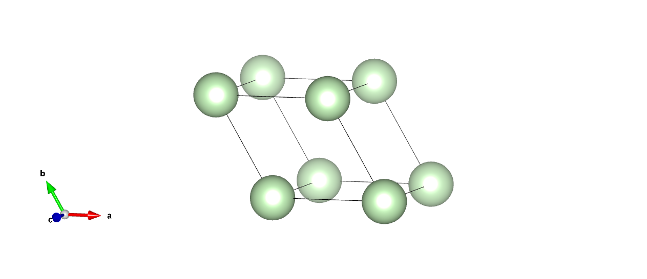

11. Primitive Monoclinic

1.0

4.0000000000 0.0000000000 0.0000000000

0.0000000000 4.5000000000 0.0000000000

1.2940952255 0.0000000000 4.8296291314

Ar

1

Direct

0.000000000 0.000000000 0.000000000

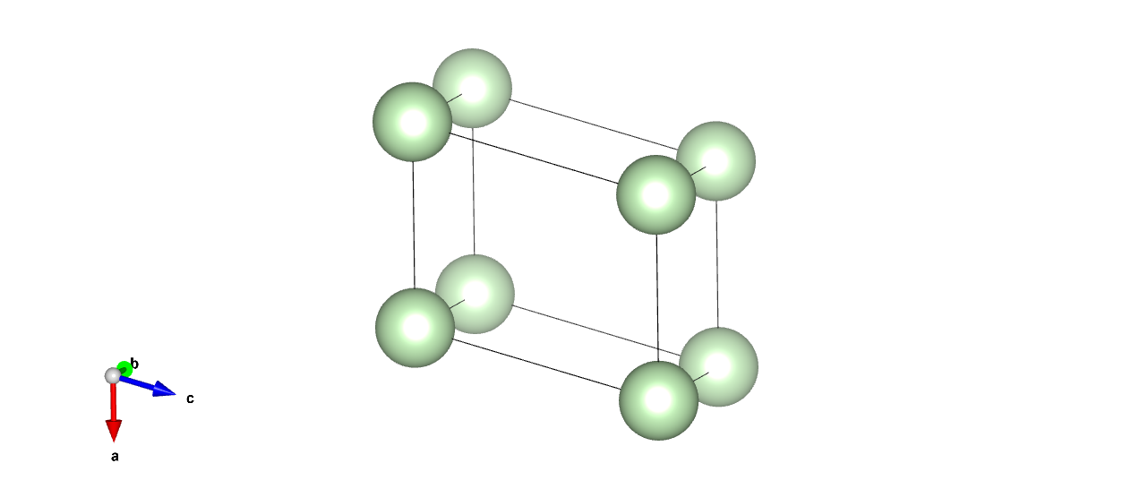

12. Base Centered Monoclinic

1.0

4.0000000000 0.0000000000 0.0000000000

0.0000000000 4.5000000000 0.0000000000

1.2940952255 0.0000000000 4.8296291314

Ar

2

Direct

0.000000000 0.000000000 0.000000000

0.000000000 0.500000000 0.500000000

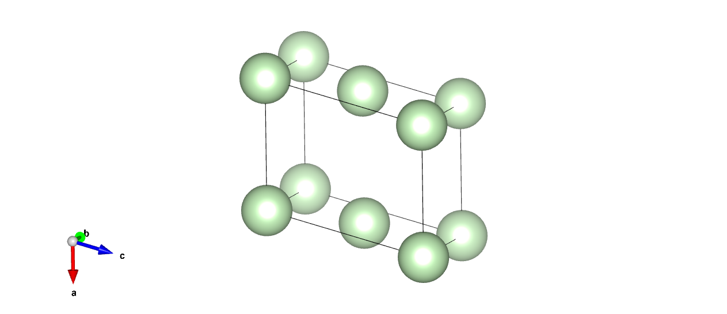

13. Trigonal Primitive

1.0

4.0000000000 0.0000000000 0.0000000000

2.2943057454 3.2766081772 0.0000000000

2.2943057454 1.1943399749 3.0511822579

Ar

1

Direct

0.000000000 0.000000000 0.000000000

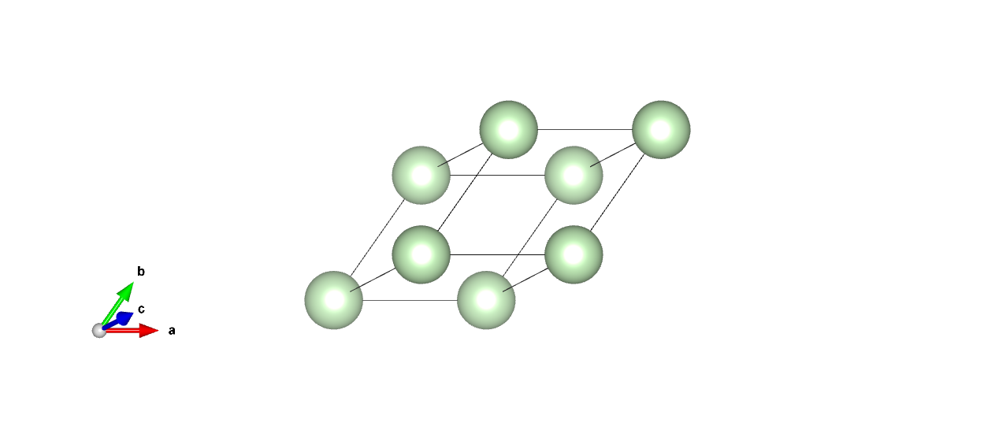

14. Primitive Triclinic

1.0

4.0000000000 0.0000000000 0.0000000000

0.7814167995 4.4316348886 0.0000000000

1.2940952255 1.5082978728 4.5880665944

Ar

1

Direct

0.000000000 0.000000000 0.000000000

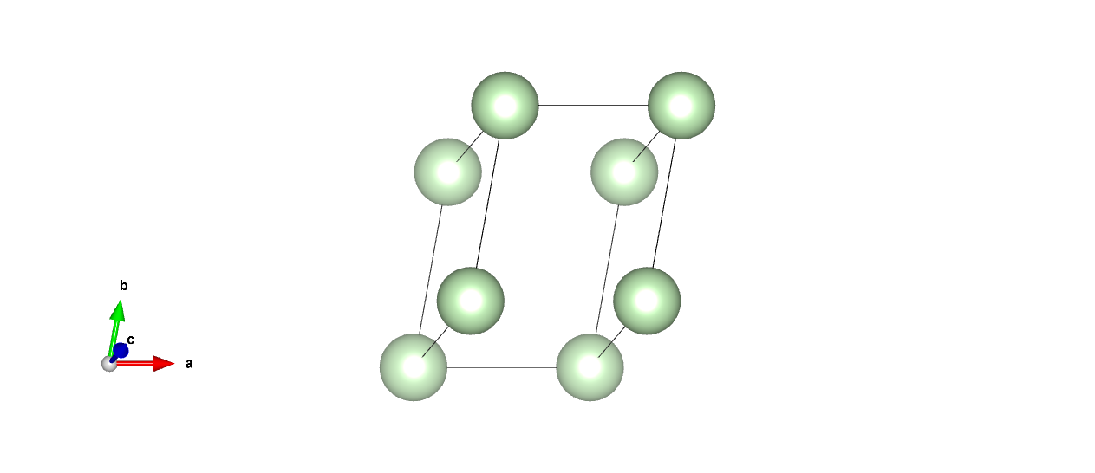

**2. Unit cells of atoms and molecules**

a. Al

1.0

4.0399999619 0.0000000000 0.0000000000

0.0000000000 4.0399999619 0.0000000000

0.0000000000 0.0000000000 4.0399999619

Al

4

Direct

0.000000000 0.000000000 0.000000000

0.000000000 0.500000000 0.500000000

0.500000000 0.000000000 0.500000000

0.500000000 0.500000000 0.000000000

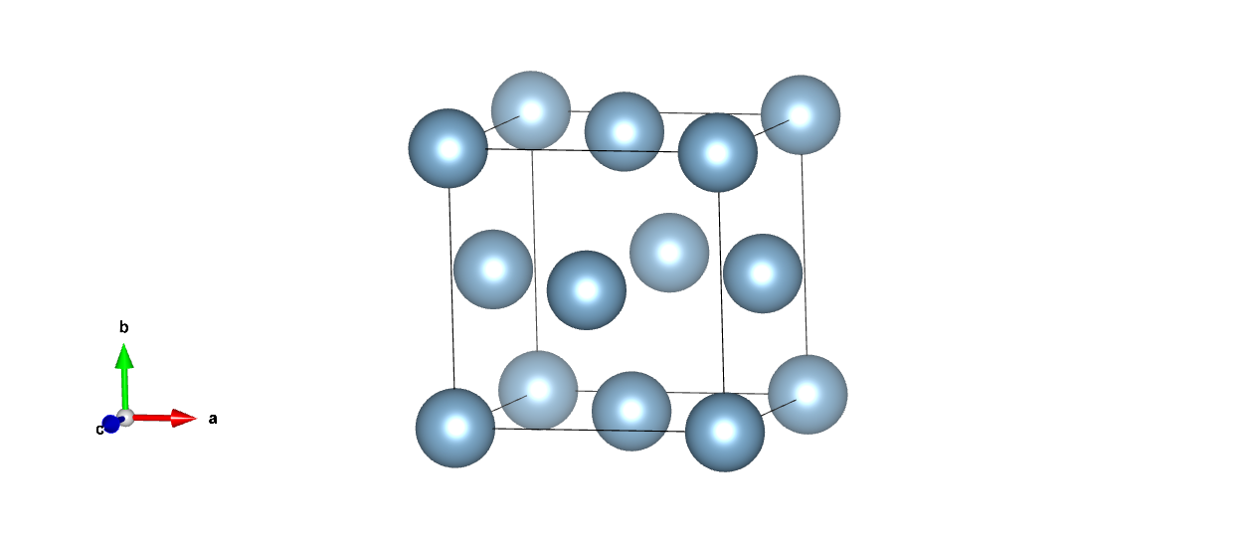

b. Ti

1.0

2.9300000668 0.0000000000 0.0000000000

-1.4650000334 2.5374544909 0.0000000000

0.0000000000 0.0000000000 4.6599998474

Ti

2

Direct

0.333333343 0.666666687 0.250000000

0.666666627 0.333333313 0.750000000

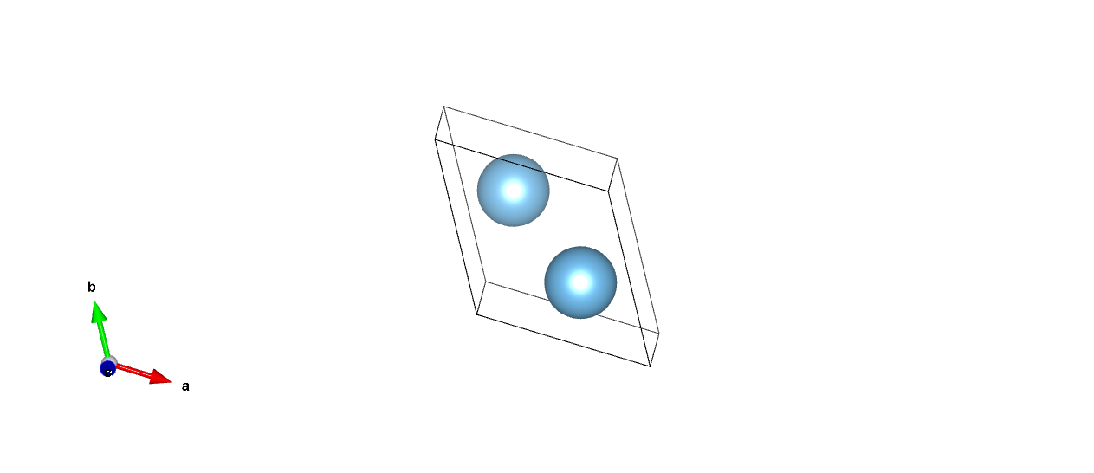

c. Ti4N3

1.0

9.9300003052 0.0000000000 0.0000000000

0.0000000000 3.0199999809 0.0000000000

-8.9469050362 0.0000000000 5.1032239028

Ti N

8 6

Direct

0.266000003 0.500000000 0.633000016

0.733999968 0.500000000 0.366999984

0.766000032 0.000000000 0.633000016

0.233999997 0.000000000 0.366999984

0.257999986 0.000000000 0.884999990

0.741999984 0.000000000 0.115000010

0.758000016 0.500000000 0.884999990

0.242000014 0.500000000 0.115000010

0.001000000 0.500000000 0.749000013

0.999000013 0.500000000 0.250999987

0.500999987 0.000000000 0.749000013

0.499000013 0.000000000 0.250999987

0.000000000 0.000000000 0.000000000

0.500000000 0.500000000 0.000000000

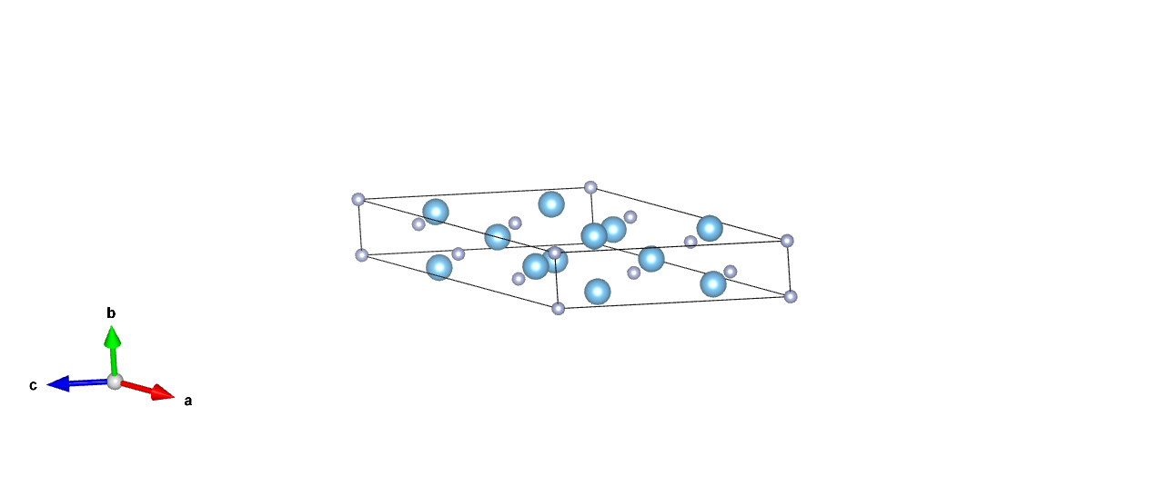

d.ZnS

1.0

5.4499998093 0.0000000000 0.0000000000

0.0000000000 5.4499998093 0.0000000000

0.0000000000 0.0000000000 5.4499998093

Zn S

4 4

Direct

0.000000000 0.000000000 0.000000000

0.000000000 0.500000000 0.500000000

0.500000000 0.000000000 0.500000000

0.500000000 0.500000000 0.000000000

0.250000000 0.250000000 0.250000000

0.750000000 0.750000000 0.250000000

0.750000000 0.250000000 0.750000000

0.250000000 0.750000000 0.750000000

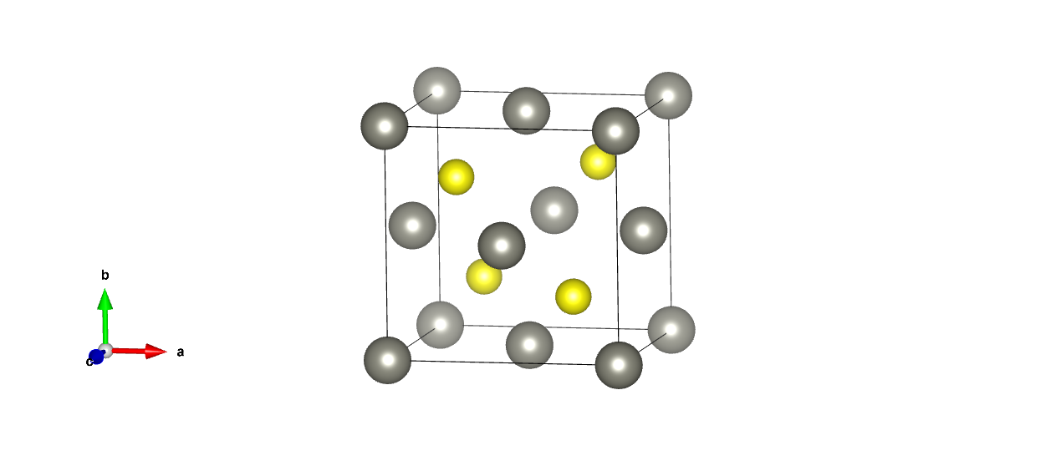

e.ZnO

1.0

3.2899999619 0.0000000000 0.0000000000

-1.6449999809 2.8492235454 0.0000000000

0.0000000000 0.0000000000 5.3099999428

Zn O

2 2

Direct

0.333333343 0.666666687 0.000000000

0.666666627 0.333333313 0.500000000

0.333333343 0.666666687 0.375000000

0.666666627 0.333333313 0.875000000

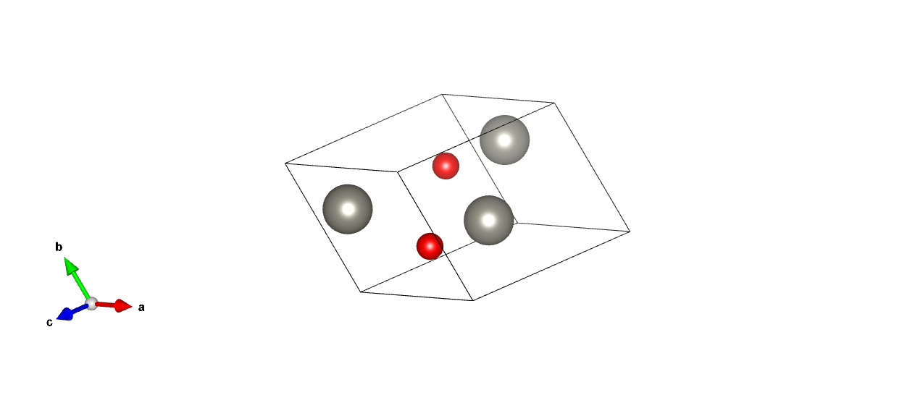

f.Lu3Al5O12

1.0

11.9700002670 0.0000000000 0.0000000000

0.0000000000 11.9700002670 0.0000000000

0.0000000000 0.0000000000 11.9700002670

Lu Al O

24 40 96

Direct

0.000000000 0.250000000 0.125000000

0.000000000 0.750000000 0.875000000

0.500000000 0.750000000 0.625000000

0.500000000 0.250000000 0.375000000

0.000000000 0.750000000 0.375000000

0.000000000 0.250000000 0.625000000

0.500000000 0.250000000 0.875000000

0.500000000 0.750000000 0.125000000

0.125000000 0.000000000 0.250000000

0.875000000 0.000000000 0.750000000

0.625000000 0.500000000 0.750000000

0.375000000 0.500000000 0.250000000

0.375000000 0.000000000 0.750000000

0.625000000 0.000000000 0.250000000

0.875000000 0.500000000 0.250000000

0.125000000 0.500000000 0.750000000

0.250000000 0.125000000 0.000000000

0.750000000 0.875000000 0.000000000

0.750000000 0.625000000 0.500000000

0.250000000 0.375000000 0.500000000

0.750000000 0.375000000 0.000000000

0.250000000 0.625000000 0.000000000

0.250000000 0.875000000 0.500000000

0.750000000 0.125000000 0.500000000

0.000000000 0.250000000 0.375000000

0.000000000 0.750000000 0.625000000

0.500000000 0.750000000 0.875000000

0.500000000 0.250000000 0.125000000

0.000000000 0.750000000 0.125000000

0.000000000 0.250000000 0.875000000

0.500000000 0.250000000 0.625000000

0.500000000 0.750000000 0.375000000

0.375000000 0.000000000 0.250000000

0.625000000 0.000000000 0.750000000

0.875000000 0.500000000 0.750000000

0.125000000 0.500000000 0.250000000

0.125000000 0.000000000 0.750000000

0.875000000 0.000000000 0.250000000

0.625000000 0.500000000 0.250000000

0.375000000 0.500000000 0.750000000

0.250000000 0.375000000 0.000000000

0.750000000 0.625000000 0.000000000

0.750000000 0.875000000 0.500000000

0.250000000 0.125000000 0.500000000

0.750000000 0.125000000 0.000000000

0.250000000 0.875000000 0.000000000

0.250000000 0.625000000 0.500000000

0.750000000 0.375000000 0.500000000

0.000000000 0.000000000 0.000000000

0.500000000 0.000000000 0.500000000

0.000000000 0.500000000 0.500000000

0.500000000 0.500000000 0.000000000

0.750000000 0.250000000 0.250000000

0.250000000 0.750000000 0.750000000

0.750000000 0.750000000 0.750000000

0.250000000 0.250000000 0.250000000

0.250000000 0.250000000 0.750000000

0.750000000 0.750000000 0.250000000

0.250000000 0.750000000 0.250000000

0.750000000 0.250000000 0.750000000

0.500000000 0.500000000 0.500000000

0.000000000 0.500000000 0.000000000

0.500000000 0.000000000 0.000000000

0.000000000 0.000000000 0.500000000

0.028999999 0.446999997 0.144999996

0.971000016 0.552999973 0.855000019

0.471000016 0.552999973 0.644999981

0.528999984 0.446999997 0.355000019

0.971000016 0.947000027 0.355000019

0.028999999 0.053000003 0.644999981

0.528999984 0.053000003 0.855000019

0.471000016 0.947000027 0.144999996

0.144999996 0.028999999 0.446999997

0.855000019 0.971000016 0.552999973

0.644999981 0.471000016 0.552999973

0.355000019 0.528999984 0.446999997

0.355000019 0.971000016 0.947000027

0.644999981 0.028999999 0.053000003

0.855000019 0.528999984 0.053000003

0.144999996 0.471000016 0.947000027

0.446999997 0.144999996 0.028999999

0.552999973 0.855000019 0.971000016

0.552999973 0.644999981 0.471000016

0.446999997 0.355000019 0.528999984

0.947000027 0.355000019 0.971000016

0.053000003 0.644999981 0.028999999

0.053000003 0.855000019 0.528999984

0.947000027 0.144999996 0.471000016

0.196999997 0.278999984 0.105000004

0.802999973 0.721000016 0.894999981

0.303000003 0.721000016 0.605000019

0.697000027 0.278999984 0.394999981

0.697000027 0.221000001 0.894999981

0.303000003 0.778999984 0.105000004

0.802999973 0.778999984 0.394999981

0.196999997 0.221000001 0.605000019

0.778999984 0.394999981 0.802999973

0.221000001 0.605000019 0.196999997

0.221000001 0.894999981 0.697000027

0.778999984 0.105000004 0.303000003

0.721000016 0.605000019 0.303000003

0.278999984 0.394999981 0.697000027

0.278999984 0.105000004 0.196999997

0.721000016 0.894999981 0.802999973

0.894999981 0.697000027 0.221000001

0.105000004 0.303000003 0.778999984

0.394999981 0.802999973 0.778999984

0.605000019 0.196999997 0.221000001

0.105000004 0.196999997 0.278999984

0.894999981 0.802999973 0.721000016

0.605000019 0.303000003 0.721000016

0.394999981 0.697000027 0.278999984

0.528999984 0.947000027 0.644999981

0.471000016 0.053000003 0.355000019

0.971000016 0.053000003 0.144999996

0.028999999 0.947000027 0.855000019

0.471000016 0.446999997 0.855000019

0.528999984 0.552999973 0.144999996

0.028999999 0.552999973 0.355000019

0.971000016 0.446999997 0.644999981

0.644999981 0.528999984 0.947000027

0.355000019 0.471000016 0.053000003

0.144999996 0.971000016 0.053000003

0.855000019 0.028999999 0.947000027

0.855000019 0.471000016 0.446999997

0.144999996 0.528999984 0.552999973

0.355000019 0.028999999 0.552999973

0.644999981 0.971000016 0.446999997

0.947000027 0.644999981 0.528999984

0.053000003 0.355000019 0.471000016

0.053000003 0.144999996 0.971000016

0.947000027 0.855000019 0.028999999

0.446999997 0.855000019 0.471000016

0.552999973 0.144999996 0.528999984

0.552999973 0.355000019 0.028999999

0.446999997 0.644999981 0.971000016

0.697000027 0.778999984 0.605000019

0.303000003 0.221000001 0.394999981

0.802999973 0.221000001 0.105000004

0.196999997 0.778999984 0.894999981

0.196999997 0.721000016 0.394999981

0.802999973 0.278999984 0.605000019

0.303000003 0.278999984 0.894999981

0.697000027 0.721000016 0.105000004

0.278999984 0.894999981 0.303000003

0.721000016 0.105000004 0.697000027

0.721000016 0.394999981 0.196999997

0.278999984 0.605000019 0.802999973

0.221000001 0.105000004 0.802999973

0.778999984 0.894999981 0.196999997

0.778999984 0.605000019 0.697000027

0.221000001 0.394999981 0.303000003

0.394999981 0.196999997 0.721000016

0.605000019 0.802999973 0.278999984

0.894999981 0.303000003 0.278999984

0.105000004 0.697000027 0.721000016

0.605000019 0.697000027 0.778999984

0.394999981 0.303000003 0.221000001

0.105000004 0.802999973 0.221000001

0.894999981 0.196999997 0.778999984

